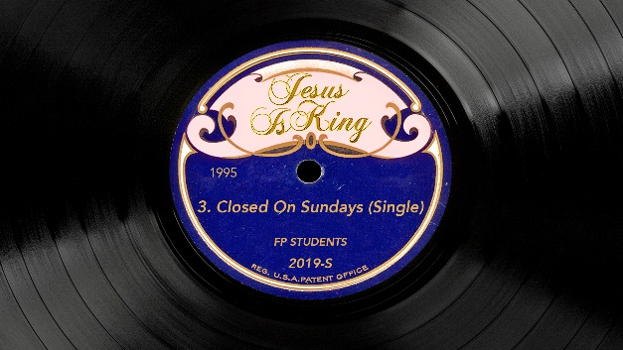

# *Jesus Is King* Week 3: Closed on Sundays

## Life / Intro Questions

* What do you think about Kayne’s album? Who’s heard it? Why did you choose to listen to it?

## Connection Questions

* Do you ever think about making an impact like Kayne?
* What makes it hard for you to use your platform, your influence, for God?

## Sermon in a Sentence

* What motivates you is written on your life.

## Scripture

**Galatians 2:20-21 The Message (MSG)**: What actually took place is this: I tried keeping rules and working my head off to please God, and it didn’t work. So I quit being a “law man” so that I could be God’s man. Christ’s life showed me how, and enabled me to do it. I identified myself completely with him. Indeed, I have been crucified with Christ. My ego is no longer central. It is no longer important that I appear righteous before you or have your good opinion, and I am no longer driven to impress God. Christ lives in me. The life you see me living is not “mine,” but it is lived by faith in the Son of God, who loved me and gave himself for me. I am not going to go back on that. Is it not clear to you that to go back to that old rule-keeping, peer-pleasing religion would be an abandonment of everything personal and free in my relationship with God? I refuse to do that, to repudiate God’s grace. If a living relationship with God could come by rule-keeping, then Christ died unnecessarily.

## Discussion Questions

* What’s motivating you to do what you do? Why?
* What keeps you from allowing love (a relationship with Jesus full of forgiveness and grace) motivate you?

## Life Application

* What beliefs do you have that need to change or lies you believe that need truth?
* What are two things you can do this week to change those lies into truths?

## Take It Out

* Encourage your students in the power of the cross. Salvation is not just about positioning us to heaven so we can prove we’re good enough to get there. It’s about being in LOVE with the savior, and that salvation is about healing, forgiveness, peace, love – the list goes on. We are motivated often by “should”… but when you’re in love you’re motivated by longing for the other person, just like a healthy marriage. Faithfulness in a marriage is not about should, it’s because you’re in love with each other. This is what a life motivated by love looks like.
* Remind your students that RIGHT NOW is the best time to register for Fusion – they need to go to fusion.events tonight and lock in the super-low $49 price. The cost will increase in early December!
* We will NOT have fpStudents next week on Nov. 27th because of Thanksgiving.